Lab Manual 4

Part A – User Creation

SQL

CREATE USER user1 IDENTIFIED BY 'password123';

SQL

CREATE USER user2 IDENTIFIED BY 'password456';

Part B – Granting Privileges

SQL

GRANT SELECT, INSERT ON Student TO user1;

SQL

GRANT ALL PRIVILEGES ON Course TO user2;

SQL

GRANT SELECT, INSERT ON Student TO user1 WITH GRANT OPTION;

Part C – Revoking Privileges

SQL

REVOKE INSERT ON Student FROM user1;

SQL

REVOKE ALL PRIVILEGES ON Course FROM user2;

Part D – User Deletion

SQL

DROP USER user2;

OBSERVATION

Login fails with authentication error since the user no longer exists in the system.

Part E – Additional Comments

SQL

SELECT User FROM mysql.user;

OUTPUT

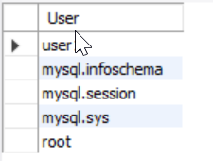

SQL

SHOW GRANTS FOR user2;

OUTPUT

